МИНИСТЕРСТВО ОБРАЗОВАНИЯ И НАУКИ

РОССИЙСКОЙ ФЕДЕРАЦИИ

ФЕДЕРАЛЬНОЕ ГОСУДАРСТВЕННОЕ АВТОНОМНОЕ ОБРАЗОВАТЕЛЬНОЕ УЧРЕЖДЕНИЕ ВЫСШЕГО ОБРАЗОВАНИЯ

«САМАРСКИЙ НАЦИОНАЛЬНЫЙ ИССЛЕДОВАТЕЛЬСКИЙ

УНИВЕРСИТЕТ ИМЕНИ АКАДЕМИКА С.П. КОРОЛЕВА»

Институт информатики и кибернетики

Кафедра геоинформатики и информационной безопасности

Отчёт по лабораторной работе №1

«VM and RAID»

Выполнил: Путилов Г.Р.

Группа: 6412-100503D

Проверил: Авдеев Е.В.

Самара 2023

**First step:**   
 Create virtual machine with debian/ubuntu/centos or download preinstalled image (<https://www.osboxes.org/>). It should be withoug GUI.

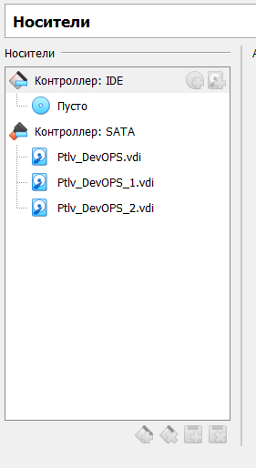

Picture 1 - Virtual machine with added disks.

**Second step:**  
 Set hostname = your surname.



Picture 2 - Set hostname

**Third step:**  
 Add simple raid1 to virtual machine: *nix os system on 1-st hdd, 2d and 3d hdds are in raid1. 1 (with star). Only two hdds. Os system on raid1, based on this two hdd.

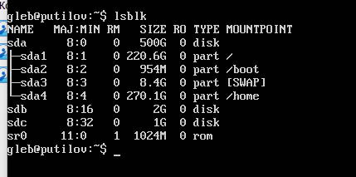

Picture 3 - Demonstration of connected sdb and sdc disks

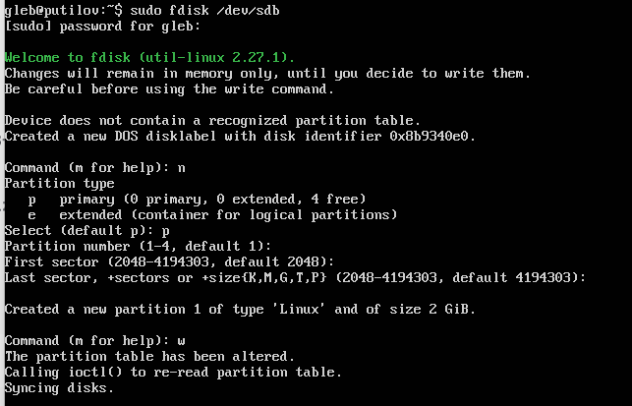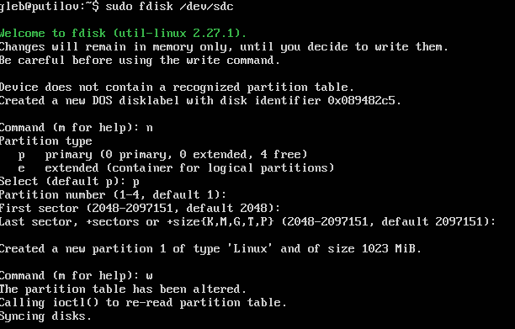

Picture 4 - Creating disk partitions on sdb and sdc

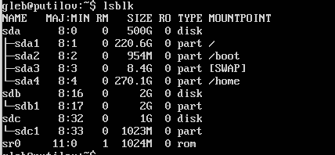

Picture 5 - Result after pic. 4

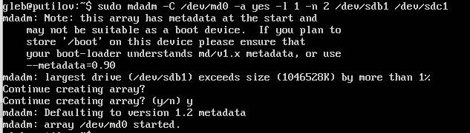

Picture 6 - Create array

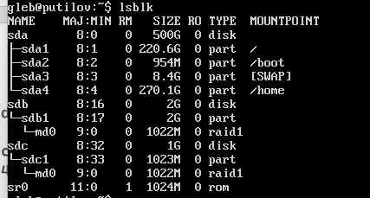

Picture 7 - Result after pic. 4

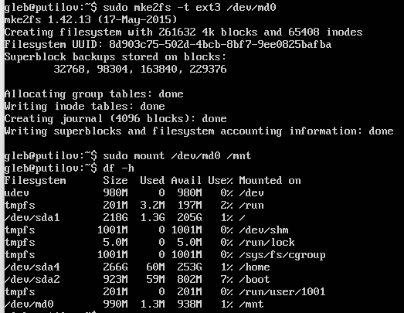

Picture 8 - Create filesystem and show result

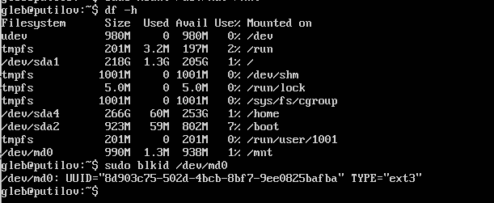

Picture 9 - Show filesystem

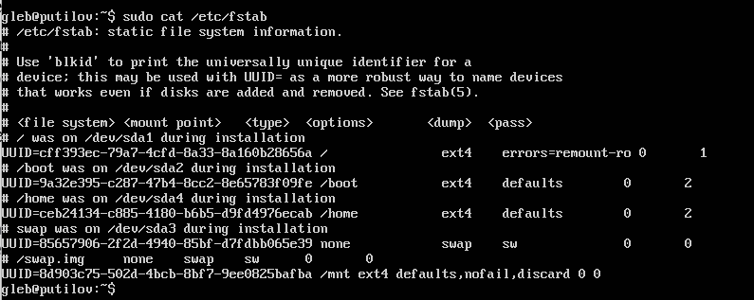

Picture 10 - Result of editing fstab

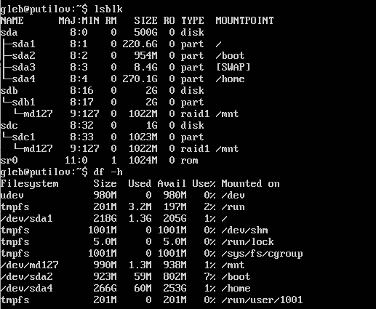

Picture 11 - After reboot

**Step fourth:**  
 Create file on raid1 file system. Turn off vm and remove one of the hhds from vm. Turn on vm. File should be accessible.

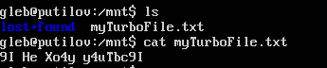

Picture 12 - Show created file

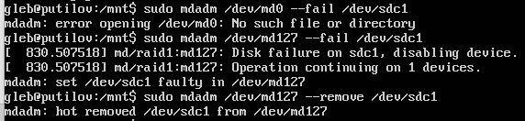

Picture 13 - Remove sdc1

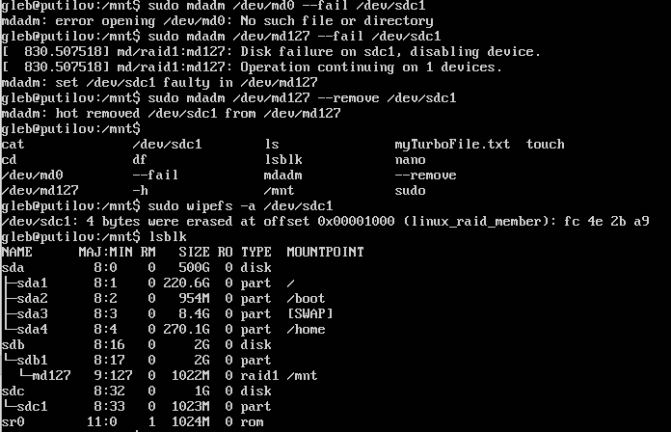

Picture 14 - Result after removing



Picture 15 - Show file

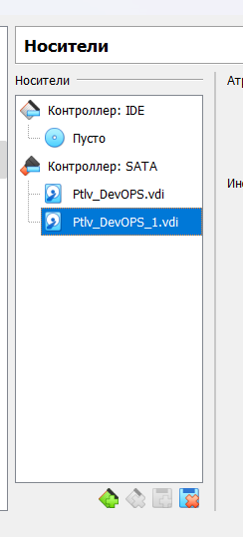

Picture 16 - Remove disk

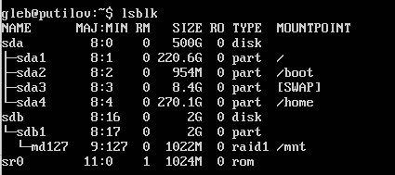

Picture 17 - Result after removing disk

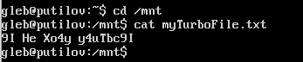

Picture 18 - Show file after removing disk

**Fifths step:**  
 Add new hdd and sync it to raid1.

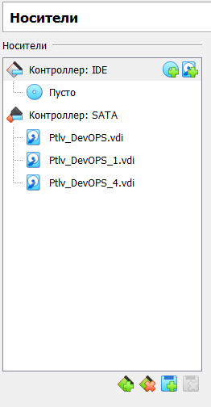

Picture 19 - Add new disk

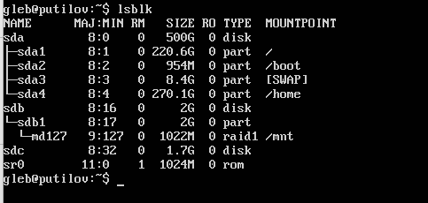

Picture 20 - Show added disk

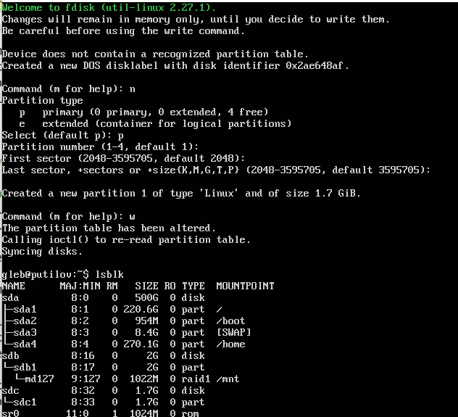

Picture 21 - Create disk partition

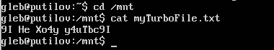

Picture 22 - Show file after all actions

**Sixth step:**  
 Install and run local Kubernetes cluster with **minikube**

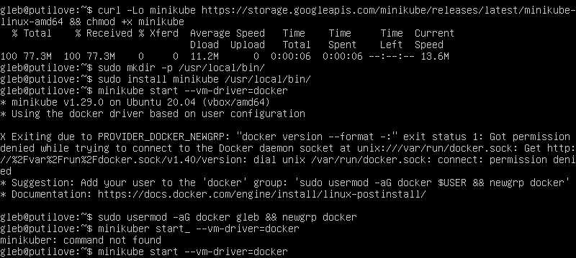

Picture 23 - Download and install minikube

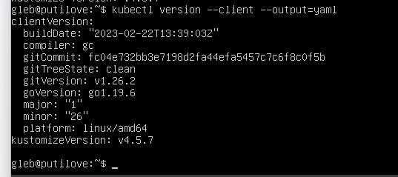

Picture 24 - Show kubectl version

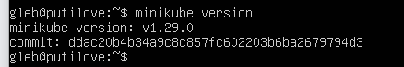

Picture 25 - Show minikube version

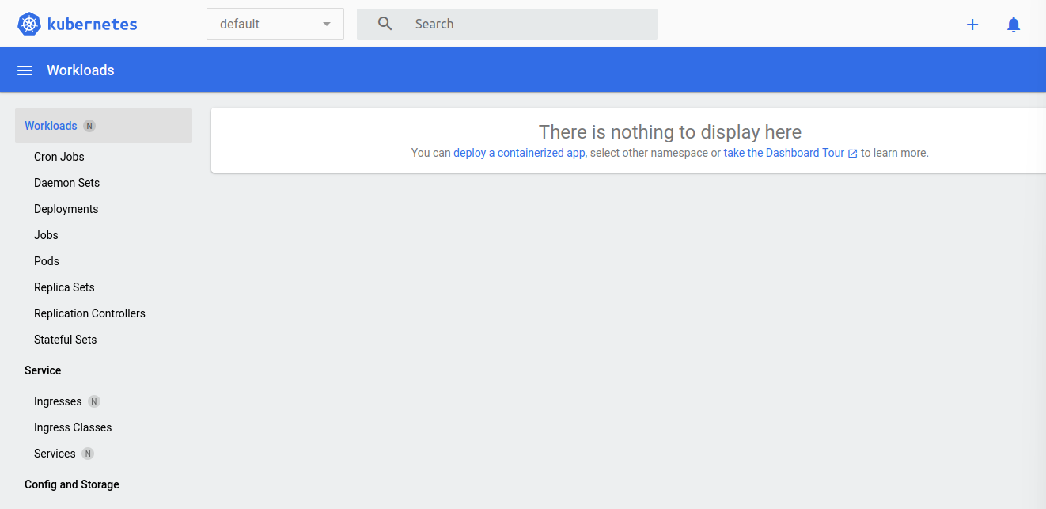

Picture 26 - Show dashboard

**Seventh step:**  
 Deploy hello-minikube app

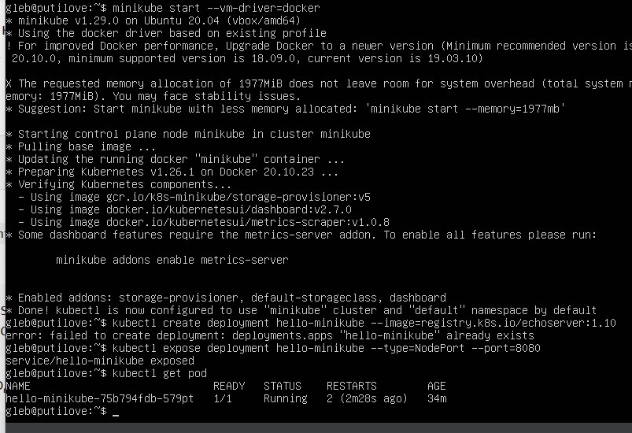

Picture 27 -Deploy app

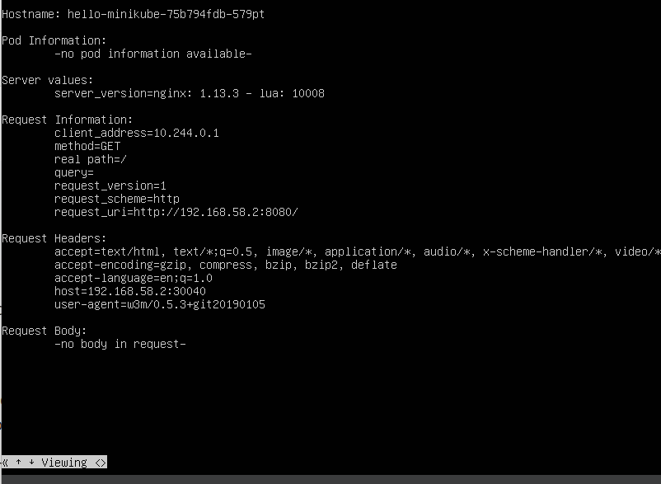

Picture 28 - Show app (in w3m browser)